**ST.XAVIER’S COLLEGE**

MAITIGHAR, KATHMANDU



**Computer Graphics**

Assignment #8

Submitted By:

Abhishek Tamrakar

013BSCCSIT003

2nd year/ 4th semester

Submitted to:

|  |  |
| --- | --- |
| Er. Anil Shah  Lecturer  Department of Computer Science |  |

**Statement:**

**PERFORM TRANSFORMATION IN THE IMAGE BY REFLECTION.**

1. **REFLECTION:**

**Algorithm:**

1. Get the width and height of the source image
2. Get parameter for reflection axis (1 for x-axis, 2 for y-axis)
3. For each point i in width

For each point j in height

If parameter==1

The translated point (x’, y’) is given by

x' = i

y’ = - j

If parameter==2

The translated point (x’, y’) is given by

x' = - i

y’ = j

Plot the points (x’, y’) with the same color as source in destination

1. Stop

**Source Code:**

//---------------------------------------------------------------------------

#include <vcl\vcl.h>

#pragma hdrstop

#include "ref.h"

//---------------------------------------------------------------------------

#pragma resource "*.dfm"

TForm1 *Form1;

int a, b, i, j, x, y;

x = Image1->Height;

y = Image1->Width;

//---------------------------------------------------------------------------

__fastcall TForm1::TForm1(TComponent* Owner)

: TForm(Owner)

{

}

//---------------------------------------------------------------------------

void __fastcall TForm1::Button1Click(TObject *Sender)

{

for(i=0;i<=x;i++)

{

for(j=0;j<=y;j++)

{

a=x-i;

b=j;

Image2->Canvas->Pixels[a][b] = Image1->Canvas->Pixels[i][j];

}

}

}

//---------------------------------------------------------------------------

void __fastcall TForm1::Button2Click(TObject *Sender)

{

for(i=0;i<=x;i++)

{

for(j=0;j<=y;j++)

{

a=i;

b=y-j;

Image3->Canvas->Pixels[a][b] = Image1->Canvas->Pixels[i][j];

}

}

}

**Output:**

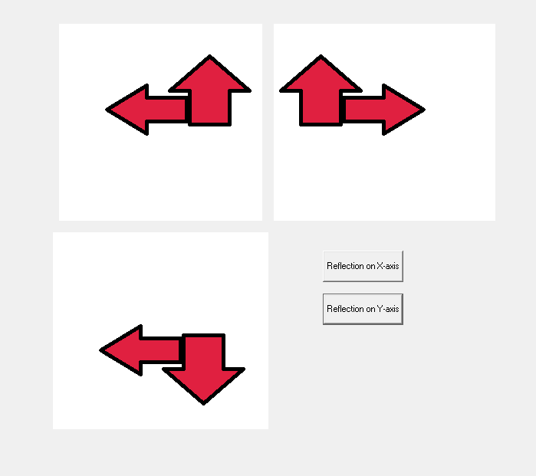

Figure I: Reflection of the Object

**Conclusion:**

Hence, reflection of object was performed using C++ Builder.